# Installation Guide for Robohelp

## Introduction

Adobe RoboHelp is a help authoring tool (HAT) developed and published by Adobe Systems for Windows. RoboHelp is an application for producing on-line documentation and the basic building block of RoboHelp is HTML file.

## Software installation requirements

The section explains the operating system, hardware, and software requirements.

### System Requirements

* Intel Pentium 4 processor.
* Microsoft Windows XP with Service Pack 3, Windows Vista with Service Pack 2, or Windows 7 32 bit and 64 bit.
* 512 MB of RAM (1 GB recommended).
* 1.2 GB of available hard-disk space for installation; additional free space required during installation.
* 1024 x 768 display (1280 x 800 recommended) with 16-bit video card.
* DVD-ROM drive.

### Supported Software

Microsoft Office 2010, 2007, or 2003

### Supported browsers

RoboHelp supports the following browsers:

* Internet Explorer (versions 9, 8, and 7)
* Firefox 3.x
* Safari 4
* Chrome

### Language Versions

The product is available in following languages

* Dutch
* English
* French
* Chinese

## Features

Latest features and enhancements in Robohelp.

|  |  |
| --- | --- |
| **Title** | **Description** |
| Automated context-sensitive help authoring | Speed up development time with automated context-sensitive help (CSH) authoring, improved Map ID, and live linking. |
| Next-generation collaboration and review workflows | Collaborate with authors, subject matter experts (SMEs), end-users and live linking of shared resources. |
| Shared reusable resources | Save time and boost productivity by reusing assets across authors and projects. |
| Community-authored content | Enrich the quality by adding Web 2.0 interactivity with enhanced Adobe AIR Help features that enable users to add comments and feedback. |
| Dynamic user-centric content | Allow users to search for relevant content that is dynamically filtered based on their role, geography, products, or operating system. |

## Installation and configuring procedure

Step by step instructions to install Robohelp.

1. 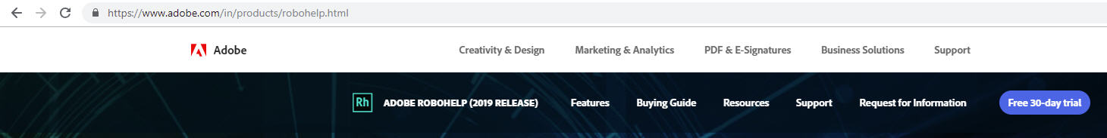Go to <https://www.adobe.com/in/products/robohelp.html> and click the **free 30-day trial** button.

Figure

1. Login to adobe download page using Gmail id.
2. Fill the required details and click the **download** button.
3. Open the installer file and double-click **Set-up.exe**.

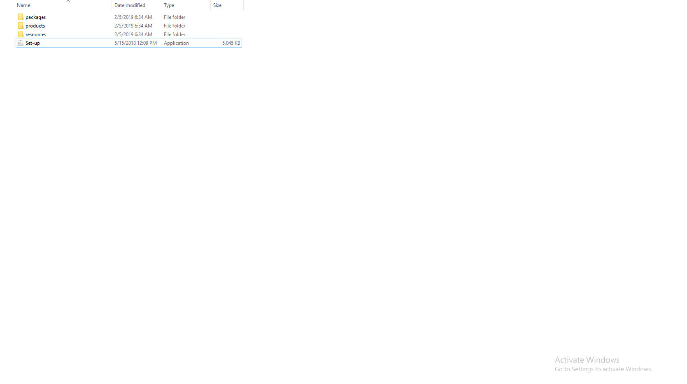

Figure

1. Sign in to Adobe Robohelp installer and click the **Continue** button.

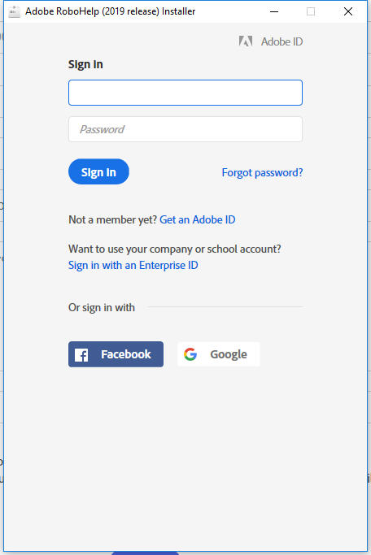

Figure

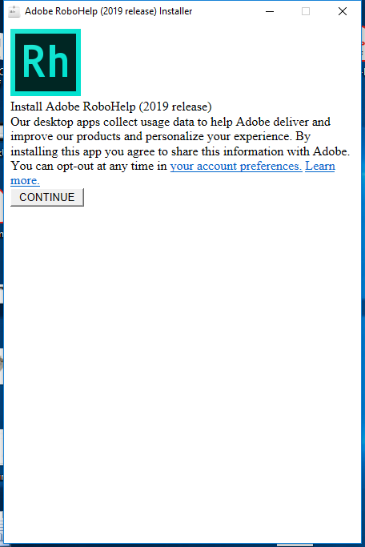

Figure

1. Select the language and location from the dropdown and click the **continue** button.
2. Once the installation is complete a pop up window appears then click the **Launch** button.

## Uninstallation

Step by step instructions to uninstall Robohelp.

* Go to control panel, click the **programs** button and click the **program and features** button.
* From the list of applications select and right-click Adobe RoboHelp file and then click the **Uninstall** button.

## Troubleshooting

The tasks in this section resolve most common installation problems.

* Try to install RoboHelp on a different computer to determine if the problem is unique. If you are able to install, contact the computer manufacturer to fix the issue in your computer.
* Use antivirus software (for example, Symantec Norton AntiVirus or McAfee VirusScan) to check the system for viruses. Virus infections can damage software and cause system errors.
* Delete temporary files using the Disk Cleanup utility. Excessive or outdated temporary files can interfere with performance of Windows or applications.
* Visit [https://forums.adobe.com/welcome to](https://forums.adobe.com/welcome%20to) see if Adobe customers are experiencing similar problems and check for alternate solutions.
* If none of the above steps resolved the error then please contact Adobe Technical Support.

*Note:* Before performing any of the above tasks, back up all personal files.